Procedure to Release Raw Material in MDEV

Create the Raw Material
- Log in as dsotest41.im
- Create the Raw Material
  - Choose to “Create Product Data” (+ > Product Specifications > Create Product Data)
  - Modify the “Type” to “Raw Material”
  - Add a “Title” and “Comment”
  - Change the value of the “Primary Organization” to “Dish Care-GLOBAL”
  - Change the value of the “Security Category Classification” to “Dish Care-R”
  - Select “OK” to create the Raw Material
- Modify the Attributes of the Raw Material
  - Select the “Edit” Button on the “Attributes” tab
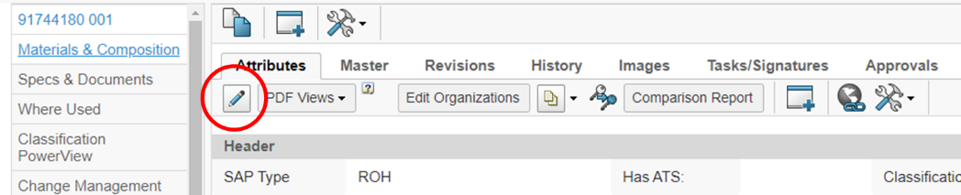
  - Update all of the Required Items: (Highlighted on Form)
- Business Area Appliances
- Product Category Platform Accessory-Device
- Structured Release Criteria Required No
- Class Accessories
- Reported Function Abrasive
- Base Unit of Measure EACH
  - Select “Done” to finalize the changes
Note: Following message appears… Select the “OK” to continue
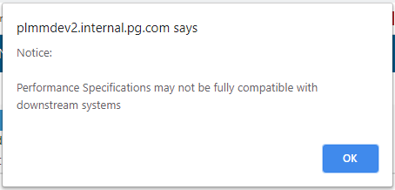

Create the Change
- Create a “Change Order”
  - Navigate to the “Change Management” page (located on the left menu)
  - Select the (*) to create a “New Change Order”
    - Add a “Description”
    - Select “OK” to create the Change Order
- Add the Routes to the Change Action
  - Select the hyperlink to the CA from the Change Order window
  - Access the Main View of the Change Action
  - Select the (+) icon on the Route Templates tab to “Manage Route Approvals”
  - Add “DXC_QA_Dish Care~Global_38 Approval” to the “In Approval” value
  - Select “Done” to complete
- Promote the “State” of the Change Action from “Prepare” to “In Work” and then to “In Approval” (Located at the top of the page)
Note: Keep a record of the Change Action

1St Approval of the Change Action
- Log in as dsotest24.im
- Select the “Pending View” to “Claim” the Route
- In the “Name/Number” add the CA number and then “Search”
- “Claim” the Change Action
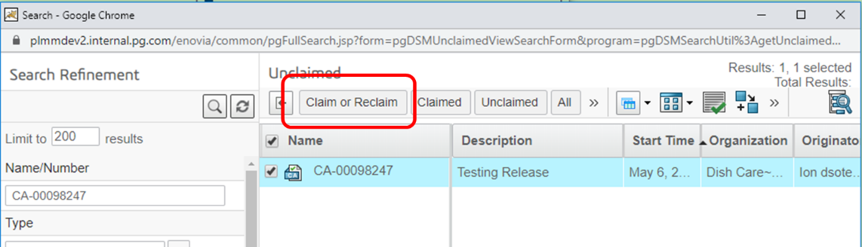
- Close the “Pending View” window
Note: The main ENOVIA window will have the Change Action open
- Navigate to the “Main Page” of the Change Action and then to the “Tasks/Signatures”
- Select the “Awaiting Approval” hyperlink in the table
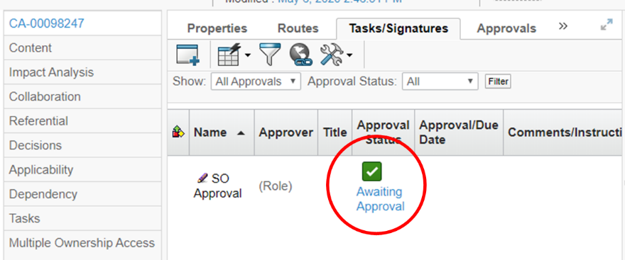
- Select the “Approve” option in the “Action” section (You will be prompt to provide your credentials also select “I understand…”)
- Navigate back to the “Content” page
- Wait for the GENDOC to be created (takes approximately 15 min)
Note: To know when the GENDOC is created, a PDF icon will appear under the “TS” column
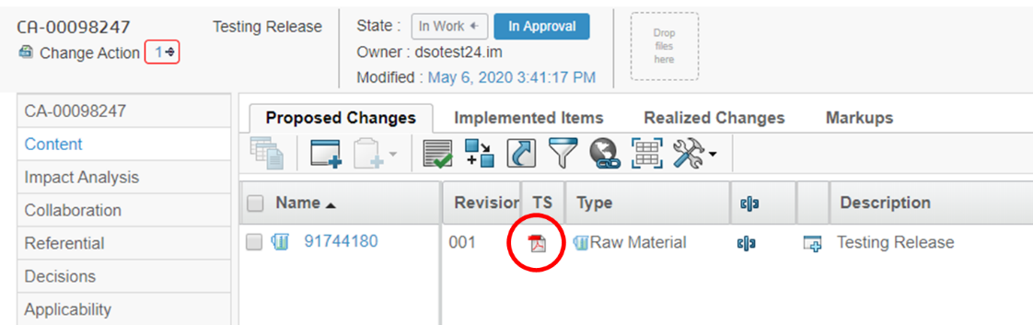

Final Approval for Change Action
- Log in as dsotest38.im
- Navigate to the “Tasks” option from the menu on the left
- Locate the Task associated to the Change Action (there is a column named “Content”)
- Select the Hyperlink to access the Task
- In the “Properties” tab, select the “Approve” icon
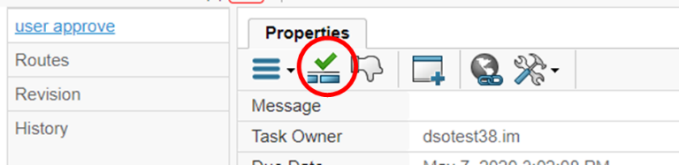
- A window will appear for you to Validate your User Credentials
The following message will appear, select the “OK” proceed.
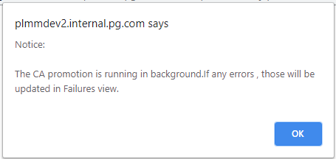

Validate the Release
Search for the Change Action and then navigate to the Raw Material
The Change Action should be “Complete”
The Raw Material should be “Released”

